|  |  |
| --- | --- |
| File:COMSATS new logo.jpg - Wikimedia Commons  Programming Fundamentals  Class Assignment 04 | **submitted by:**  **Shahzaneer Ahmed**  **registration number:**  **sp21-bcs-087**  **submitted to:**  **Mr. rizwan rashid**  **date of submission:**  **december 29, 2021** |

Question 1

# Source Code

*//------------SHAHZANEER AHMED------------------------  
//----------------SP21-BCS-087------------------------  
//------------Class Assignment 04---------------------  
  
//QUESTION #1 (CLO-3)  
//  
// Write a Java program to keep accepting 10 integer values from user until valid values are entered.  
// If the user enters invalid integer values then ask the user to enter it again.  
// For example if the given input is as below…  
// 11  
// 2  
// 99  
// 21abc  
//  
// Then your program should ask the user to enter the fourth value again as it is invalid  
// .User should not be asked to enter the valid values again.  
//  
// Once all the values are entered then sort these values in ascending order.  
  
import java.util.Arrays*;  
*import java.util.Scanner*;  
*public class Question1* {  
 *public static void* main(*String*[] *args*) {  
 *Scanner* input = *new* Scanner(*System*.in);  
 *int* [] arr = *new int*[10];  
 *for*(*int* i = 0; i< arr.length;i++){  
 *try*{  
 *System*.out.printf("Enter an element at %dth position ",i);  
 *int* number = input.nextInt();  
 arr[i] = number;  
 }  
 *catch* (*Exception e*){  
 *System*.out.printf("invalid input! kindly enter the value at %dth position again! \n",i);  
 *String* x = input.nextLine(); *// it will temporarily store the invalid input (Buffer Scenezz)* i--; *// loop main chunkay abhi aik barhayga but error ki soorat main hum dubara same iteration per  
 // repeat krna chahtay hain tou aik kam krdengay.* }  
 }  
 *sorting*(arr);  
  
 *System*.out.println(*Arrays*.*toString*(arr));  
 }  
 *public static void* sorting(*int* [] *arr*){  
 *for* (*int* i = 0; i< *arr*.length;i++){  
 *for*(*int* j=i+1; j<*arr*.length;j++){  
 *if*(*arr*[i]>*arr*[j]){  
*// swapping  
 int* temp = *arr*[i];  
 *arr*[i] = *arr*[j];  
 *arr*[j] = temp;  
 }  
 }  
 }  
  
 }  
  
}

# Output

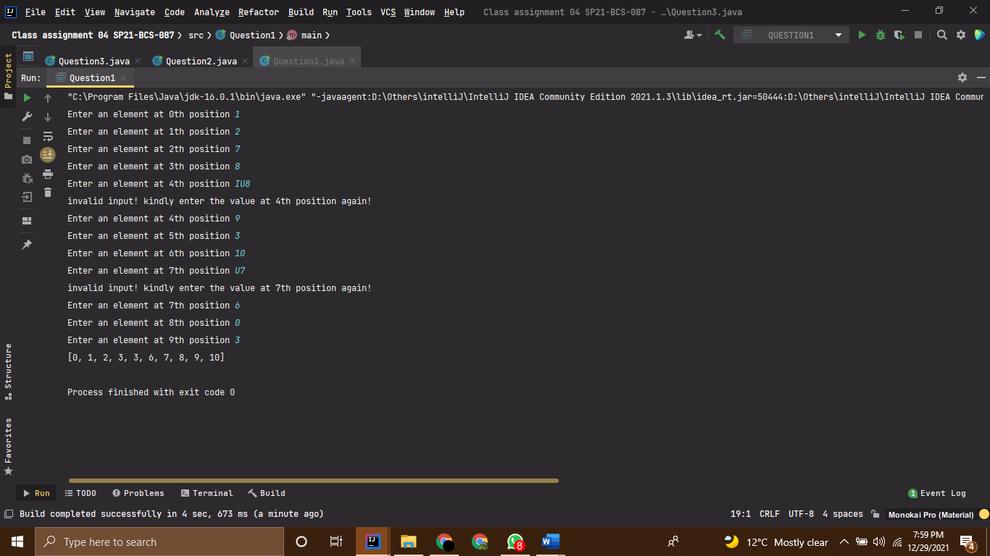

Question 2

# Source Code

*//------------SHAHZANEER AHMED------------------------  
//----------------SP21-BCS-087------------------------  
//------------Class Assignment 04---------------------  
  
//QUESTION #2 (CLO-3)  
//  
// Write a method that returns the sum of all the elements in a specified column in a matrix using the following header:  
//  
//public static double sumColumn(double[][] m, int columnIndex)  
//  
// Write a test program that reads a 3-by-4 matrix and displays the sum of each  
// column. Here is a sample run:  
  
  
import java.util.Scanner*;  
*public class Question2* {  
 *public static void* main(*String*[] *args*) {  
 *Scanner* input = *new* Scanner(*System*.in);  
 *System*.out.println("Enter the size of rows :");  
 *int* rows = input.nextInt();  
 *System*.out.println("Enter the size of columns :");  
 *int* columns = input.nextInt();  
  
 *double* [][] arr = *new double*[rows][columns];  
 *System*.out.println("Enter the elements in your 2D array :");  
 *for*(*int* i=0; i< arr.length;i++){  
 *for*(*int* j = 0; j< arr[i].length;j++){  
 *System*.out.printf("Enter Element at position at %dth row %dth column :",i,j);  
 arr[i][j] = input.nextDouble();  
 }  
 }  
  
 *for*(*int* i = 0; i<columns;i++){  
 *double* sum = *sumColumn*(arr,i);  
 *System*.out.printf("The sum of column %d is %.1f\n",i,sum);  
 }  
  
 }  
 *public static double* sumColumn(*double* [][] *arr*, *int columnNumber*){  
 *double* sum = 0;  
 *for*(*int* i = 0; i<*arr*.length;i++){  
 *for*(*int* j = 0; j<*arr*[i].length;j++){  
 *if* (j == *columnNumber*){  
 sum+=*arr*[i][j];  
 }  
 }  
 }  
 *return* sum;  
 }  
}

# Output

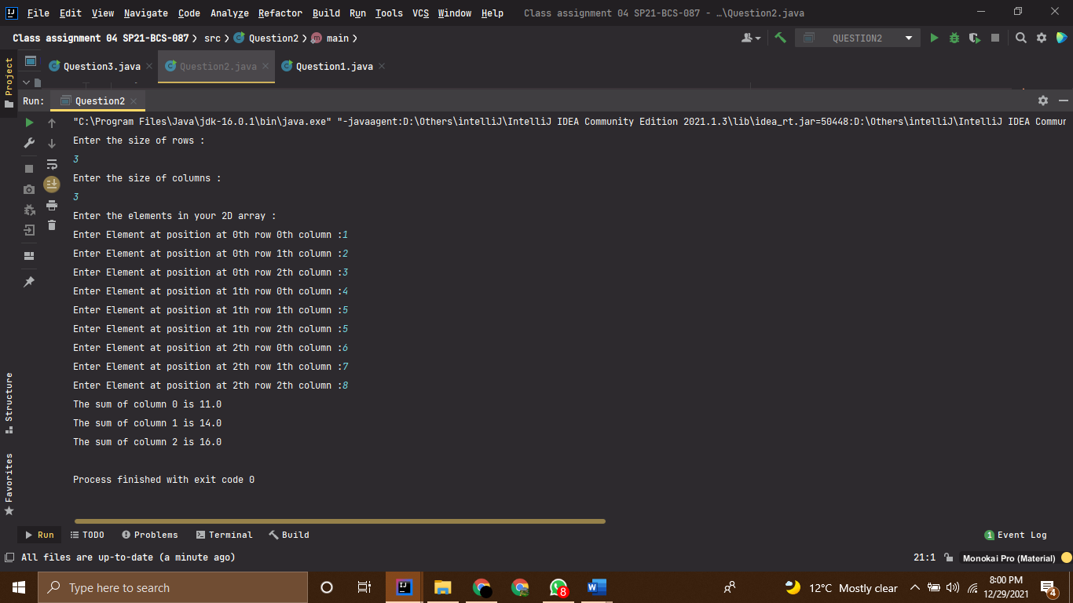

Question 3

# Source Code

*//------------SHAHZANEER AHMED------------------------  
//----------------SP21-BCS-087------------------------  
//------------Class Assignment 04---------------------  
  
//QUESTION #3 (CLO-3)  
//  
// Write a method that sums all the numbers in the major diagonal in an n * n matrix of double  
// values using the following header:  
//  
//public static double sumMajorDiagonal(double[][] m)  
//  
// Write a test program that reads a 4-by-4 matrix and displays the sum of all its elements on the major diagonal.  
// Here is a sample run:  
  
  
import java.util.Scanner*;  
*public class Question3* {  
 *public static void* main(*String*[] *args*) {  
 *Scanner* input = *new* Scanner(*System*.in);  
 *System*.out.println("Enter the size of rows :");  
 *int* rows = input.nextInt();  
 *System*.out.println("Enter the size of columns :");  
 *int* columns = input.nextInt();  
  
 *double* [][] arr = *new double*[rows][columns];  
 *System*.out.println("Enter the elements in your 2D array :");  
 *for*(*int* i=0; i< arr.length;i++){  
 *for*(*int* j = 0; j< arr[i].length;j++){  
 *System*.out.printf("Enter Element at position at %dth row %dth column :",i,j);  
 arr[i][j] = input.nextDouble();  
 }  
 }  
  
  
 *double* sum = *sumMajorDiagonal*(arr);  
 *System*.out.printf("The sum of Major diagonal is %.1f\n",sum);  
  
  
 }  
  
 *public static double* sumMajorDiagonal(*double*[][] *arr*) {  
 *double* Majorsum = 0;  
 *for*(*int* i = 0; i<*arr*.length;i++){  
 *for*(*int* j = 0; j<*arr*[i].length;j++){  
 *if* (i==j){  
 Majorsum+=*arr*[i][j];  
 }  
 }  
 }  
 *return* Majorsum;  
 }  
 }

# Output

